3DM-GX1 set to continuous mode, Gyro-Stabilized Euler angles (Command Byte 0E)
11 bytes per set of data
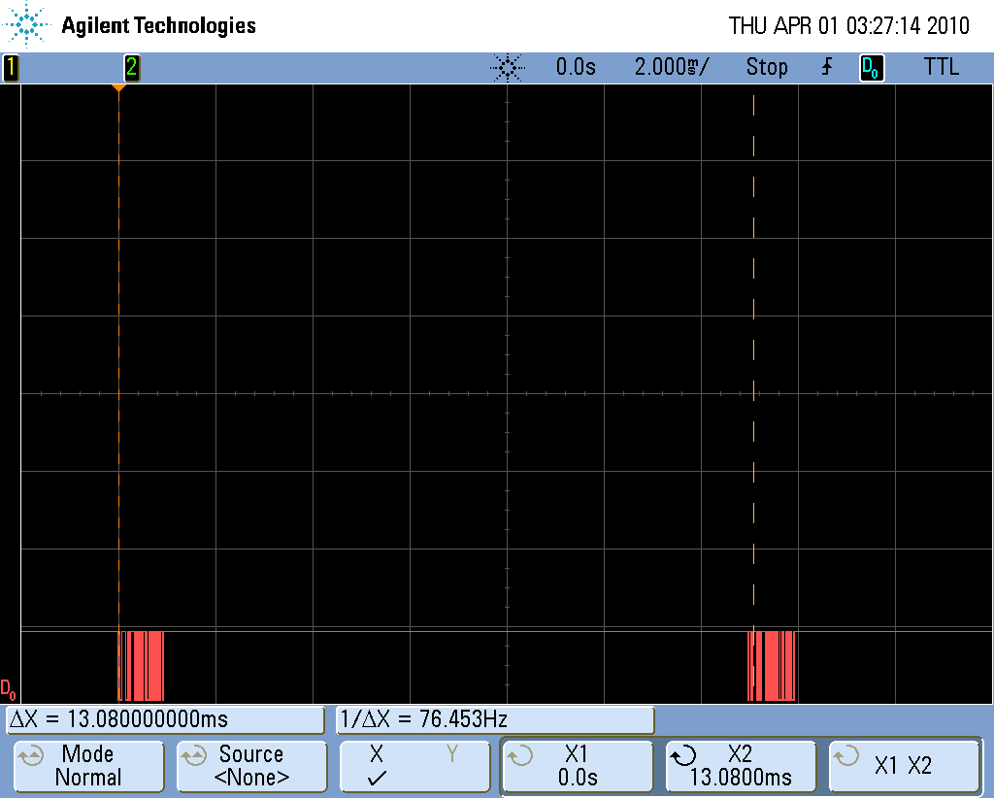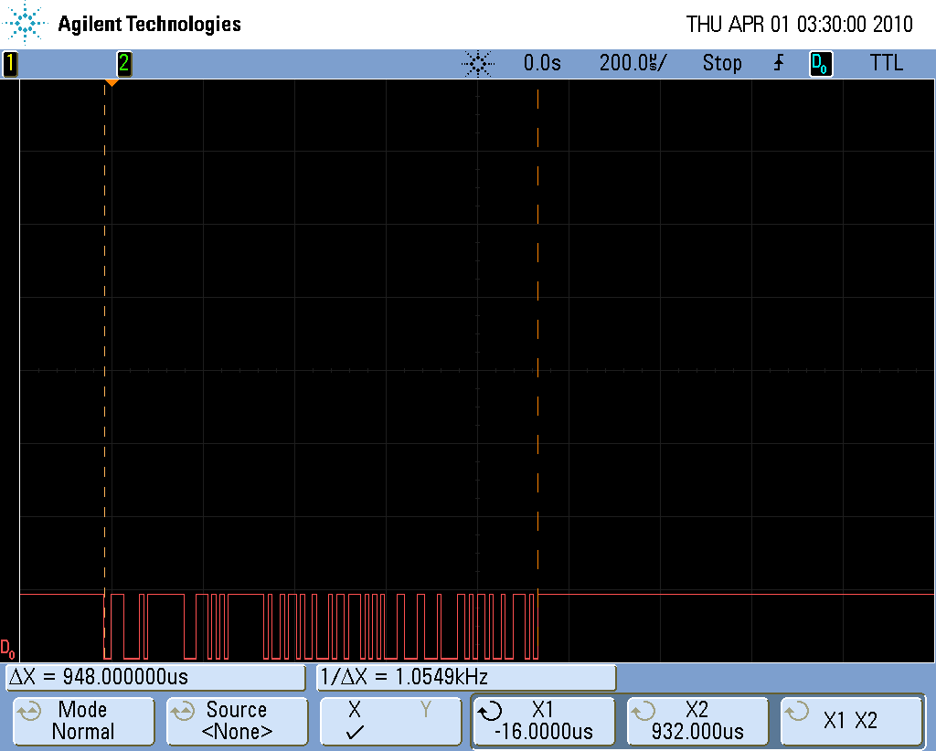
Figure 1: 13ms update rate Figure 2: one data set (11 bytes) takes 948us

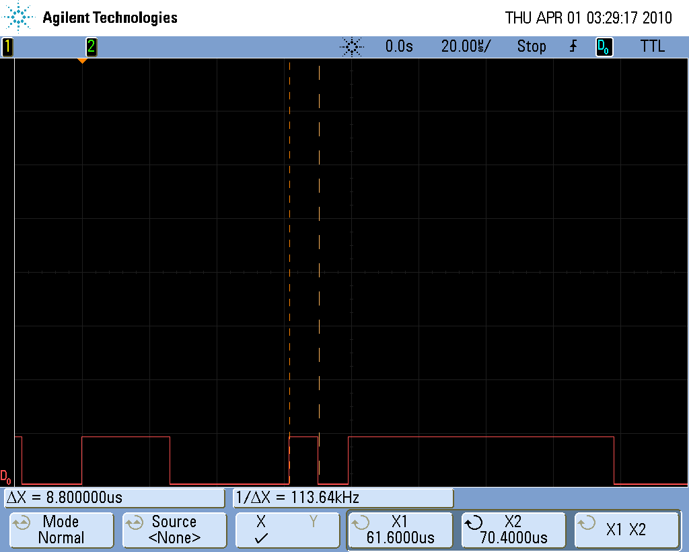 Typical Data: 0E FF 48 FF 72 A4 2C 8F 73 32 67
Figure 3: one bit takes 9us at 115200 baud
Set duration calculation: 11 bytes/set * (8 data + 1 stop) * 9us/bit = 891us

